**HTML**

**ASSIGNMENT:2**

**Q1.** What are the benefits of using CSS?

**ANS.** Benefits of CSS are :

* CSS plays an important role, by using CSS you simply got to specify a repeated style for element once & use it multiple times as because CSS will automatically apply the required styles.
* The main advantage of CSS is that style is applied consistently across variety of sites. One instruction can control several areas which is advantageous.
* Cascading sheet not only simplifies website development, but also simplifies the maintenance as a change of one line of code affects the whole web site and maintenance time.
* It is less complex therefore the effort are significantly reduced.
* It helps to form spontaneous and consistent changes.
* It has the power for re-positioning. It helps us to determine the changes within the position of web elements who are there on the page.
* Easy for the user to customize the online page
* It reduces the file transfer size.

**Q2.** What are the disadvantages of CSS?

**ANS.**

* CSS, CSS 1 up to CSS3, result in creating of confusion among web browsers.
* With CSS, what works with one browser might not always work with another. The web developers need to test for compatibility, running the program across multiple browsers.
* There exists a scarcity of security.
* After making the changes we need to confirm the compatibility if they appear. The similar change affects on all the browsers.
* The programming language world is complicated for non-developers and beginners. Different levels of CSS i.e. CSS, CSS 2, CSS 3 are often quite confusing.
* Browser compatibility some styles sheet are supported and some are not.
* There might be cross-browser issues while using CSS.
* There are multiple levels which creates confusion for non-developers and beginners.

**Q3.** What is the difference between CSS2 and CSS3?

**ANS.**

|  |  |
| --- | --- |
| **CSS2** | **CSS3** |
| CSS is capable of positioning texts and objects. | On the other hand, CSS3 is capable of making the web page more attractive and takes less time to create. CSS3 is backward compatible with CSS. |
| Responsive designing is not supported in CSS. | CSS3 is the latest version, hence it supports responsive design. |
| CSS cannot be split into modules. | Whereas CSS3 can be breakdown into modules. |
| CSS does not support media queries. | But CSS3 supports media queries. |
| CSS is memory intensive. | CSS3 memory consumption is low as compared to CSS. |

**Q4.** Name a few CSS style components.

**ANS.** CSS style components are:

1. Selectors
2. Properties
3. Values
4. Units
5. Selectors Combinators
6. Media Queries

**Q5.** What do you understand by CSS opacity?

**ANS.** CSS opacity refers to the transparency level of an element on a web page. It allows you to control how transparent or opaque an element and its content are. The opacity property in CSS can take values from 0 to 1, where 0 represents fully transparent and 1 represents fully opaque.

When you set the opacity of an element to a value less than 1, it becomes partially transparent, allowing whatever is behind it to show through. This can be useful for creating visual effects, such as overlays, fading effects, or highlighting elements.

**Q6.** How can the background color of an element be changed?

**ANS.** The background-color property of CSS is used to set the background of an element. We can set background color by selecting the element by its class name of id name and then apply the background-color property on it to set the background color.

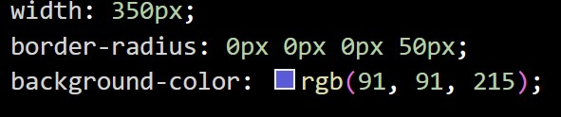

**Q7.** How can image repetition of the backup be controlled?

**ANS.** This task can be achieved by using the background-repeat property that will help us to control the repetition of the image. The background-repeat property in CSS is used to repeat the background image both horizontally and vertically. It also decides whether the background image will be repeated or not.



**Q8.** What is the use of the background-position property?

**ANS.** The background-position property in CSS is mainly used to sets the initial position for the background image ie., it is used to set an image at a certain position. The position that is relative to the positioning layer, can be set by using the background-origin property.

**Q9.** Which property controls the image scroll in the background?

**ANS.** To control the scrolling behavior of a background image, you can use the background-attachment property in CSS.

This property determines whether the background image scrolls with the content of the element or remains fixed relative to the viewport.

**Q10.** Why should background and color be used as separate properties?

**ANS.** Separating the background and color properties in CSS allows for greater flexibility and control over the styling of elements on a webpage. Here are several reasons why it's beneficial to use them separately:

* **Modularity and Maintainability:** Separating background properties from color properties makes the code more modular and easier to maintain. If you need to change the background color or image of an element, you can do so without affecting its text color, and vice versa.
* **Clarity and Readability:** Separating background and color properties improves the readability of the CSS code. It makes it clearer what aspect of the element's appearance each property is controlling, enhancing code understanding and collaboration among developers.

**Q11.** How to center block elements using CSS1?

ANS. Center block elements using margin property: We need to specify the margin from left and right such that it looks centered. We do not need to do this manually, we have one property value “auto” which will automatically set the margin such that our block element is placed in the center.

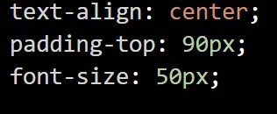

**Q12.** How to maintain the CSS specifications?

**ANS.** Maintaining CSS specifications involves several best practices to ensure consistency, scalability, and ease of maintenance across your project. Here are some guidelines:

**Consistent Naming Conventions:** Adopt a consistent naming convention for CSS classes and IDs across your project. This makes it easier to understand the purpose of each style rule and facilitates collaboration among developers. Popular naming conventions include BEM (Block Element Modifier), SMACSS (Scalable and Modular Architecture for CSS), and OOCSS (Object-Oriented CSS).

**Use CSS Preprocessors:** Utilize CSS preprocessors like Sass, LESS, or Stylus to enhance the maintainability and productivity of your CSS code. Preprocessors offer features such as variables, mixins, nesting, and inheritance, which help streamline styling tasks and reduce code duplication.

**Q13.** What are the ways to integrate CSS as a web page?

**ANS.** There are several ways to integrate CSS into a web page. Here are the most common methods:

**Embedded CSS:** You can include CSS directly within the HTML document using the <style> tag in the <head> section. This method is suitable for small-scale styling that applies only to a single page.

**External CSS:** You can create a separate CSS file with the .css extension and link it to your HTML document using the <link> tag in the <head> section. This method is recommended for larger projects or when you want to reuse styles across multiple pages.

**Inline CSS:** You can apply CSS directly to individual HTML elements using the style attribute. This method is suitable for applying unique styles to specific elements.

**Q14.** What is embedded style sheets?

**ANS.** Embedded style sheets refer to CSS code that is directly included within an HTML document using the <style> element in the <head> section. This method allows you to define styles specific to a single HTML document without the need for external CSS files.

* CSS styles for the <body>, <h1>, and <p> elements are defined within the <style> element in the <head> section.
* The styles defined inside the <style> element apply only to the HTML document in which they are embedded.
* You can use any valid CSS syntax within the embedded style sheets to style the elements of the HTML document.

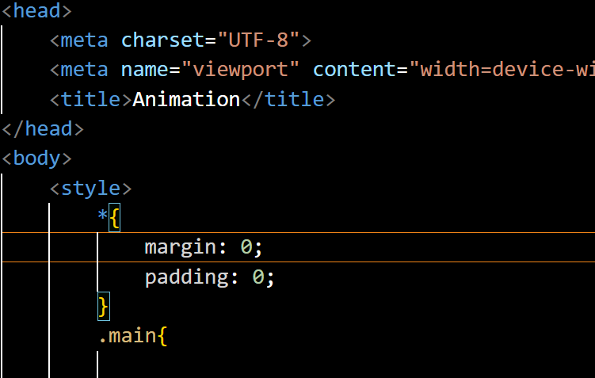

**Q15.** What are the external style sheets?

**ANS.** External style sheets are CSS files that contain styles for one or more HTML documents. These CSS files are separate from the HTML documents and are linked to them using the <link> element in the <head> section of the HTML document. This method allows for the separation of content (HTML) and presentation (CSS), making it easier to maintain and update styles across multiple pages.

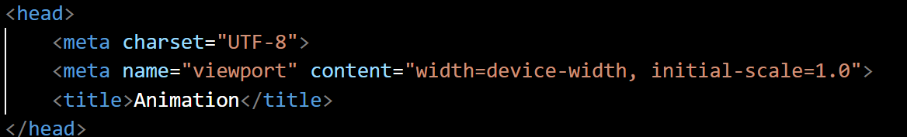



**Q16.** What are the advantages and disadvantages of using external style sheets?

**ANS. Advantages of CSS:**

* CSS plays an important role, by using CSS you simply got to specify a repeated style for element once & use it multiple times as because CSS will automatically apply the required styles.
* The main advantage of CSS is that style is applied consistently across variety of sites. One instruction can control several areas which is advantageous.
* Web designers needs to use few lines of programming for every page improving site speed.
* Cascading sheet not only simplifies website development, but also simplifies the maintenance as a change of one line of code affects the whole web site and maintenance time.

**Disadvantages of CSS:**

* CSS, CSS 1 up to CSS3, result in creating of confusion among web browsers.
* With CSS, what works with one browser might not always work with another. The web developers need to test for compatibility, running the program across multiple browsers.
* There exists a scarcity of security.
* After making the changes we need to confirm the compatibility if they appear. The similar change affects on all the browsers.

**Q17.** What is the meaning of the CSS selector?

**ANS.** CSS Selectors targets the HTML elements on the Pages to add styles. CSS selectors select HTML elements according to their id, class, type, attribute, etc. Selectors play a crucial role in defining the appearance and layout of web pages, enhancing both aesthetics and user experience.

Types Of Selectors are:

1. Simple Selectors
2. Element Selector
3. Id Selector
4. Class Selector
5. Universal Selector
6. Group Selector
7. Attribute Selector
8. Pseudo-Class Selector
9. Pseudo-Element Selector

**Q18.** What are the media types allowed by CSS?

**Ans.** CSS supports different media types, allowing styles to be applied based on the characteristics of the output device. The main media types allowed by CSS are:

1. All
2. Print
3. Screen
4. Speech

**Q19.** What is the rule set?

**Ans.** A CSS ruleset is various affirmations to various pieces or elements of the document. The objective is to apply a bunch of properties for certain distinct qualities to a solitary, or a particular arrangement of components in the connected HTML page.

**Q20.** Create layouts.

**Ans.** [**https://github.com/bhumika2348/CSS/blob/main/display2.html**](https://github.com/bhumika2348/CSS/blob/main/display2.html)